Spring boot additional questions:

What would happen if bean is not found ?
If @Autowired(Required = true)

APPLICATION FAILED TO START
***************************
Description:
Field requestScopedBean in com.scope.demo.ScopeRestController required a bean of type 'com.scope.demo.HelloWorldBean' that could not be found.
The injection point has the following annotations:
- @org.springframework.beans.factory.annotation.Autowired(required=true)

If @Autowired(Required=false)
Tomcat starts and application starts successfully.
When we try to access the method:
java.lang.NullPointerException: Cannot invoke "com.scope.demo.HelloWorldBean.getMessage()" because "this.requestScopedBean" is null

Code Review:
Indentation and readability of the code.
Proper UT documents and which files were changed and what was changed should be attached.
Provide suggestions if I have a better way of doing something. For example , sometime people hardcode string within the code at multiple places then as a reviewer I request them to store them in one place. May be in an interface as public static final.
We also verify that the build generated is stable. Jenkins report build as unstable if any vulnerabilities are present.
We also check that proper variable names are used and remove unwanted logs.
Also verify if before calling any function of an object, are we doing any null checks. If not then , in extreme cases the code might fail.

Advantages of Spring Boot:
It tests web applications easily with the help of different Embedded HTTP servers such as Tomcat, Jetty, etc. We don't need to deploy WAR files.
It provides opinionated 'starter' POMs.
It provides production-ready features such as metrics, health checks,and externalized configuration.
No XML config.

Limitations of Spring Boot
Spring Boot can use dependencies that are not going to be used in the application. These dependencies increase the size of the application.
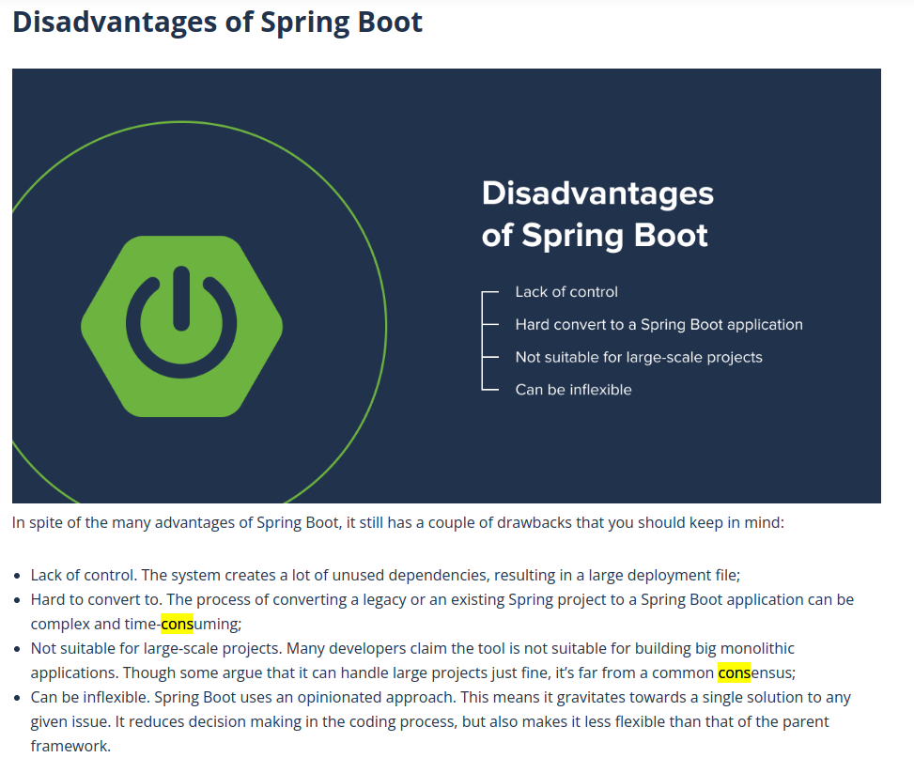
Prod Issues I have faced:
-> One of the teamate left organisation and , few issues were reported in his application like he was running a while loop while reading some data from the table. He was running a select query and initializing the variables. The issue was if we the query is success then variables will hold the latest values but if the select statement could not find the row then variables wont change their values and same set of values will be processed again, resulting duplication. I dentified it and provided the fix and a seperate package was deployed in prod.
-> ComCode
-> CircuitBreaker

How to remove cyclic dependency using @PostConstruct annotations ?
Spring calls methods the annotated with @PostConstruct only once after the initialization of bean properties. ‘

How to connect multiple databases from 1 microservice?
https://www.youtube.com/watch?v=LKxu7TY1gD8

